Ryan, Oscar (1904-1989)

The leading cultural activist in the Canadian Communist party in the 1930s, Oscar Ryan was the formative figure in the Workers’ Theatre movement in Canada and a tireless advocate of revolutionary theatrical modernism. Born Oscar Weinstein, he took his underground name from his mother’s maiden name, Rein. He grew up in Montreal and Winnipeg and after high school joined the Young Communist League as a full-time party activist. With an idiomatic and forceful proletarian writing style in the manner of John Dos Passos and Mike Gold, he became a writer for the Communist Party’s Daily Worker and its successors, the Daily Clarion and the Canadian Tribune. As Martin Stone, he was a theatre critic for the Tribune from 1955 to 1988. In the Communist Party of Canada, he was an early supporter of Tim Buck, who took over the party in 1929 when communist parties around the world assumed a more radical militant stance in answer to Stalin’s call for revolutionary class war. Under Buck, Ryan became a leading figure in the party’s propaganda wing, a cultural organizer, publicity director of the Canadian Labor Defence League, and the author of numerous pamphlets. His published work includes the agitprop play Unity (1932), the novel Soon to be Born (1980), and a hagiographic biography of Tim Buck. At Ryan’s initiative and direction, the Toronto Workers Theatre wrote and produced the first major Canadian documentary agitprop play, Eight Men Speak (1933); Ryan was one of four co-authors.

Considered the high point of revolutionary modernism in Canadian theatre, Eight Men Speak combined familiar agitprop techniques of mass chant, spotlight dramaturgy, telegraphic dialogue, and parody with documentary realism as part of a campaign to advocate for the release of imprisoned Communist leaders. Ryan was the principal director of the play, and played the iconic figure of the ‘Workers’ Judge.’ The Toronto police, on orders from the Prime Minister of Canada, banned the play after its first performance; Ryan’s attempt to remount it in Winnipeg the following year was also aborted by police intervention.

Ryan met his life partner, Toby Gordon, in the Workers Theatre and married in 1949. Toby Gordon Ryan’s memoir, Stage Left is the most complete, if politically circumspect, account of the Workers Theatre and the production of Eight Men Speak.

List of Works

Ryan, Oscar. (1980) Soon to be Born, Vancouver: New Star.

----- Unity. (1976) Eight Men Speak and Other Plays from the Canadian Workers’ Theatre, ed. Robin Endres and Richard Wright, Toronto: New Hogtown Press, 97-106.

----- (1975) Tim Buck: A Conscience for Canada, Toronto: Progress Books.

Ryan, Oscar, E. Cecil-Smith, Mildred Goldberg, and Frank Love. (2014) Eight Men Speak: A Political Play in Six Acts, ed. and with an introduction by Alan Filewod, Ottawa: University of Ottawa Press.

References and Further Reading

Adams, Rose. (1988) “Oscar Ryan (27 June 1904--),” Canadian Writers, 1920-1959, First Series, ed. W.H. New, Dictionary of Literary Biography, vol 68, Detroit: Gale Research, 318-323.

Filewod, Alan. (1996) “The Comintern and the Canon: Workers' Theatre, Eight Men Speak and the Genealogy of Mise-en-Scène,” Australasian Drama Studies 29 (Oct.): 17-32.

----- (2003) “Performance and Memory in the Party: Dismembering the Workers’ Theatre Movement,” Essays in Canadian Writing 80 (Fall): 59-77.

Gomez, Mayte. (1999) “In Anger and Hope: Oscar Ryan at the Canadian Tribune, 1955-1988,” Establishing Our Boundaries: English-Canadian Theatre Criticism, ed. Anton Wagner, Toronto: University of Toronto Press, 254-267.

Ontario Historical Studies Series (OHSS). (1976) “Oscar Ryan and Toby Ryan.” Interview by Don Rubin, 23 June 1976, transcript. Archives of Ontario. RG 47-27-2-32.

Ryan, Toby Gordon. (1981) Stage Left: Canadian Theatre in the Thirties: A Memoir, Toronto, CTR Publications.

Alan Filewod, University of Guelph

Recommended Illustrations

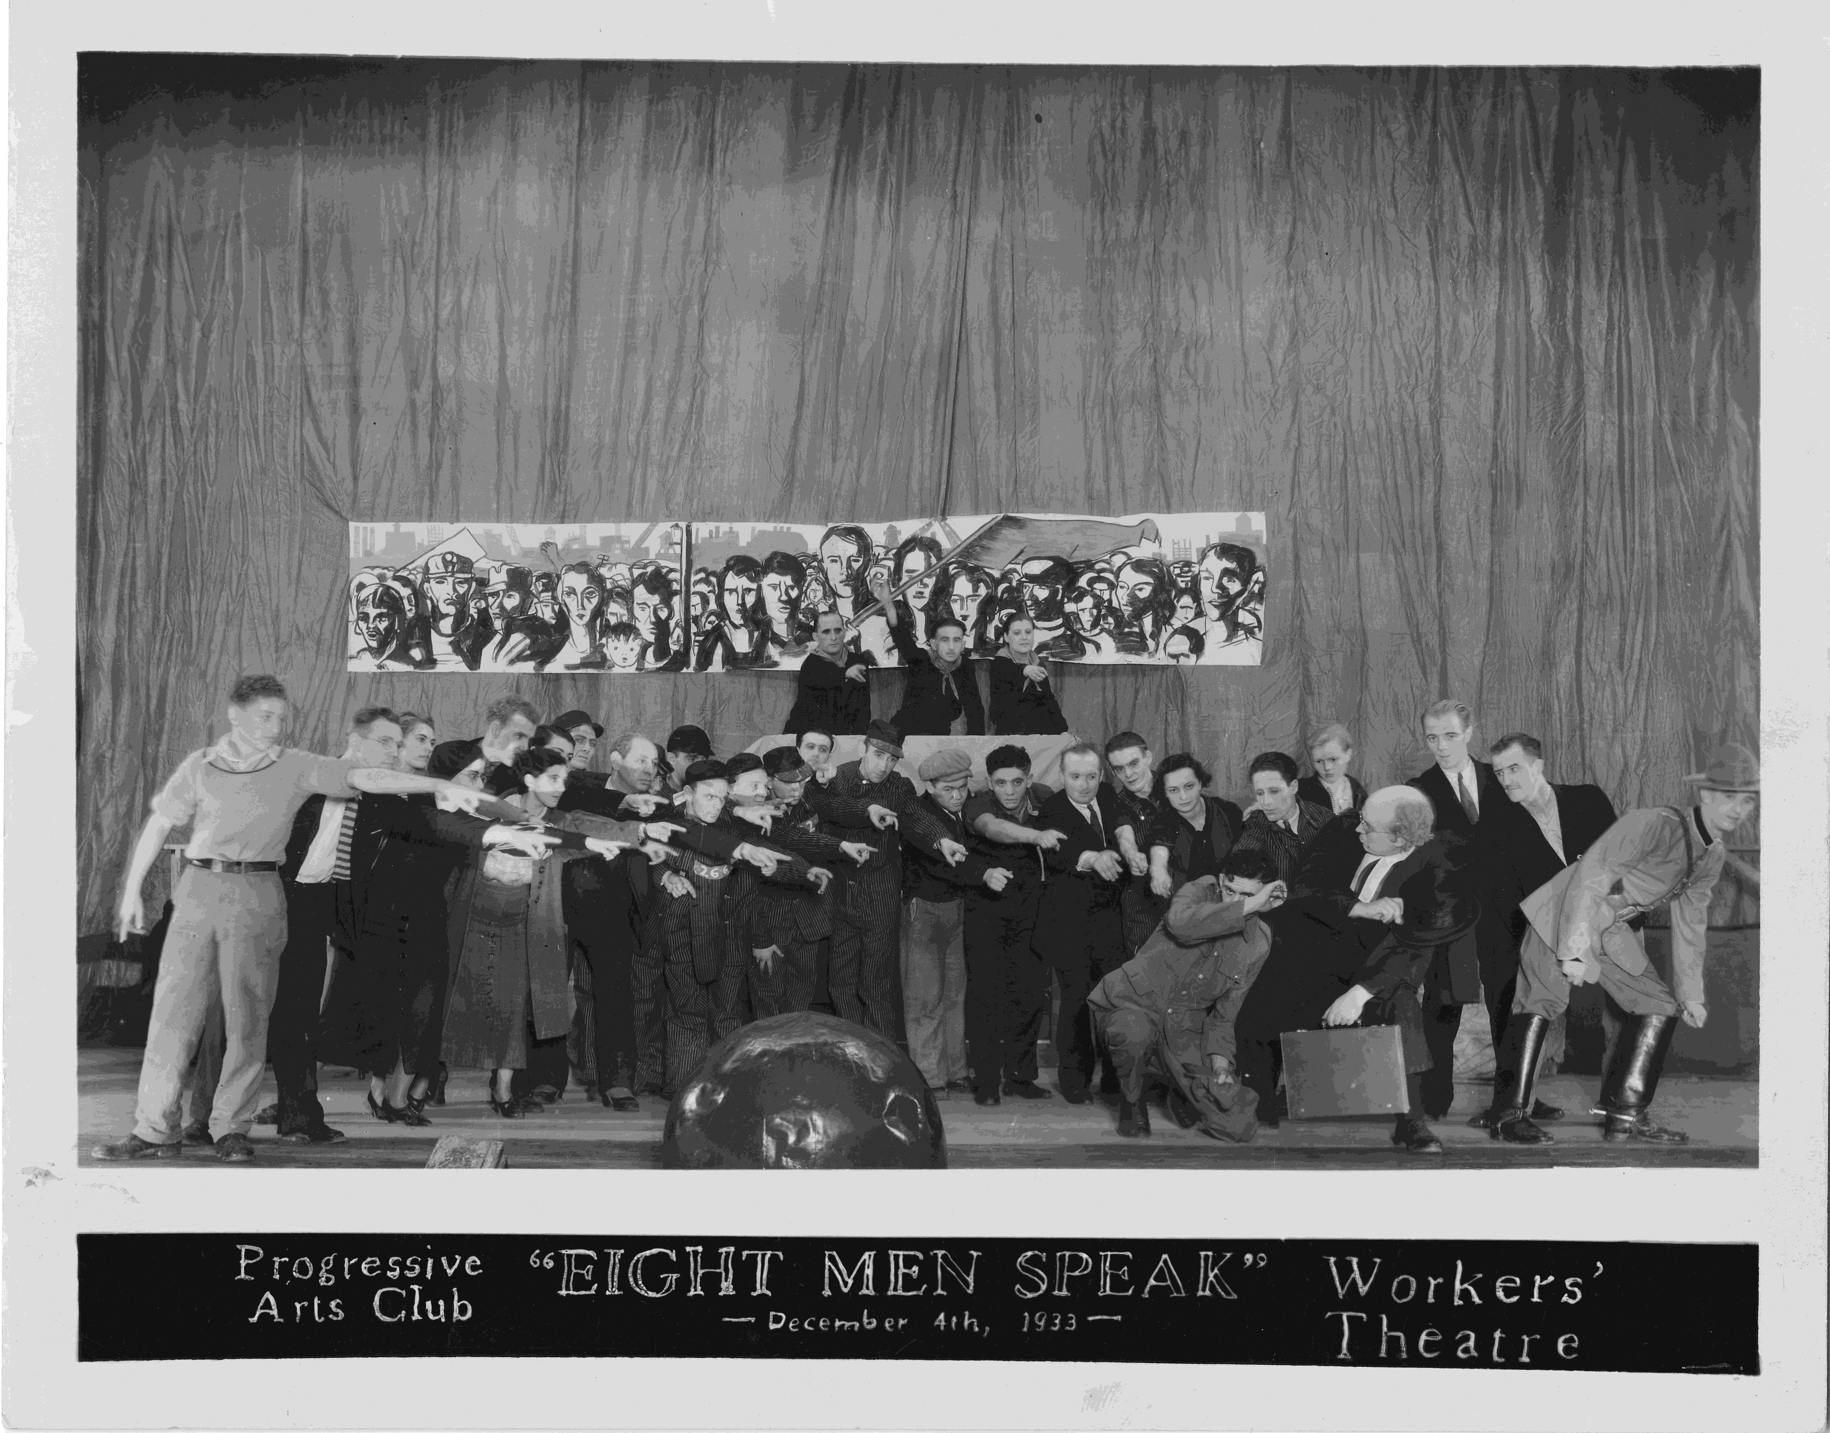

The Workers Theatre production of Eight Men Speak in Toronto, Dec. 4, 1933. Oscar Ryan presides (centre at podium, with raised fist) as the Workers’ Judge.
[Source: L.W. Conolly Theatre Archives, McLaughlin Library, University of Guelph.]
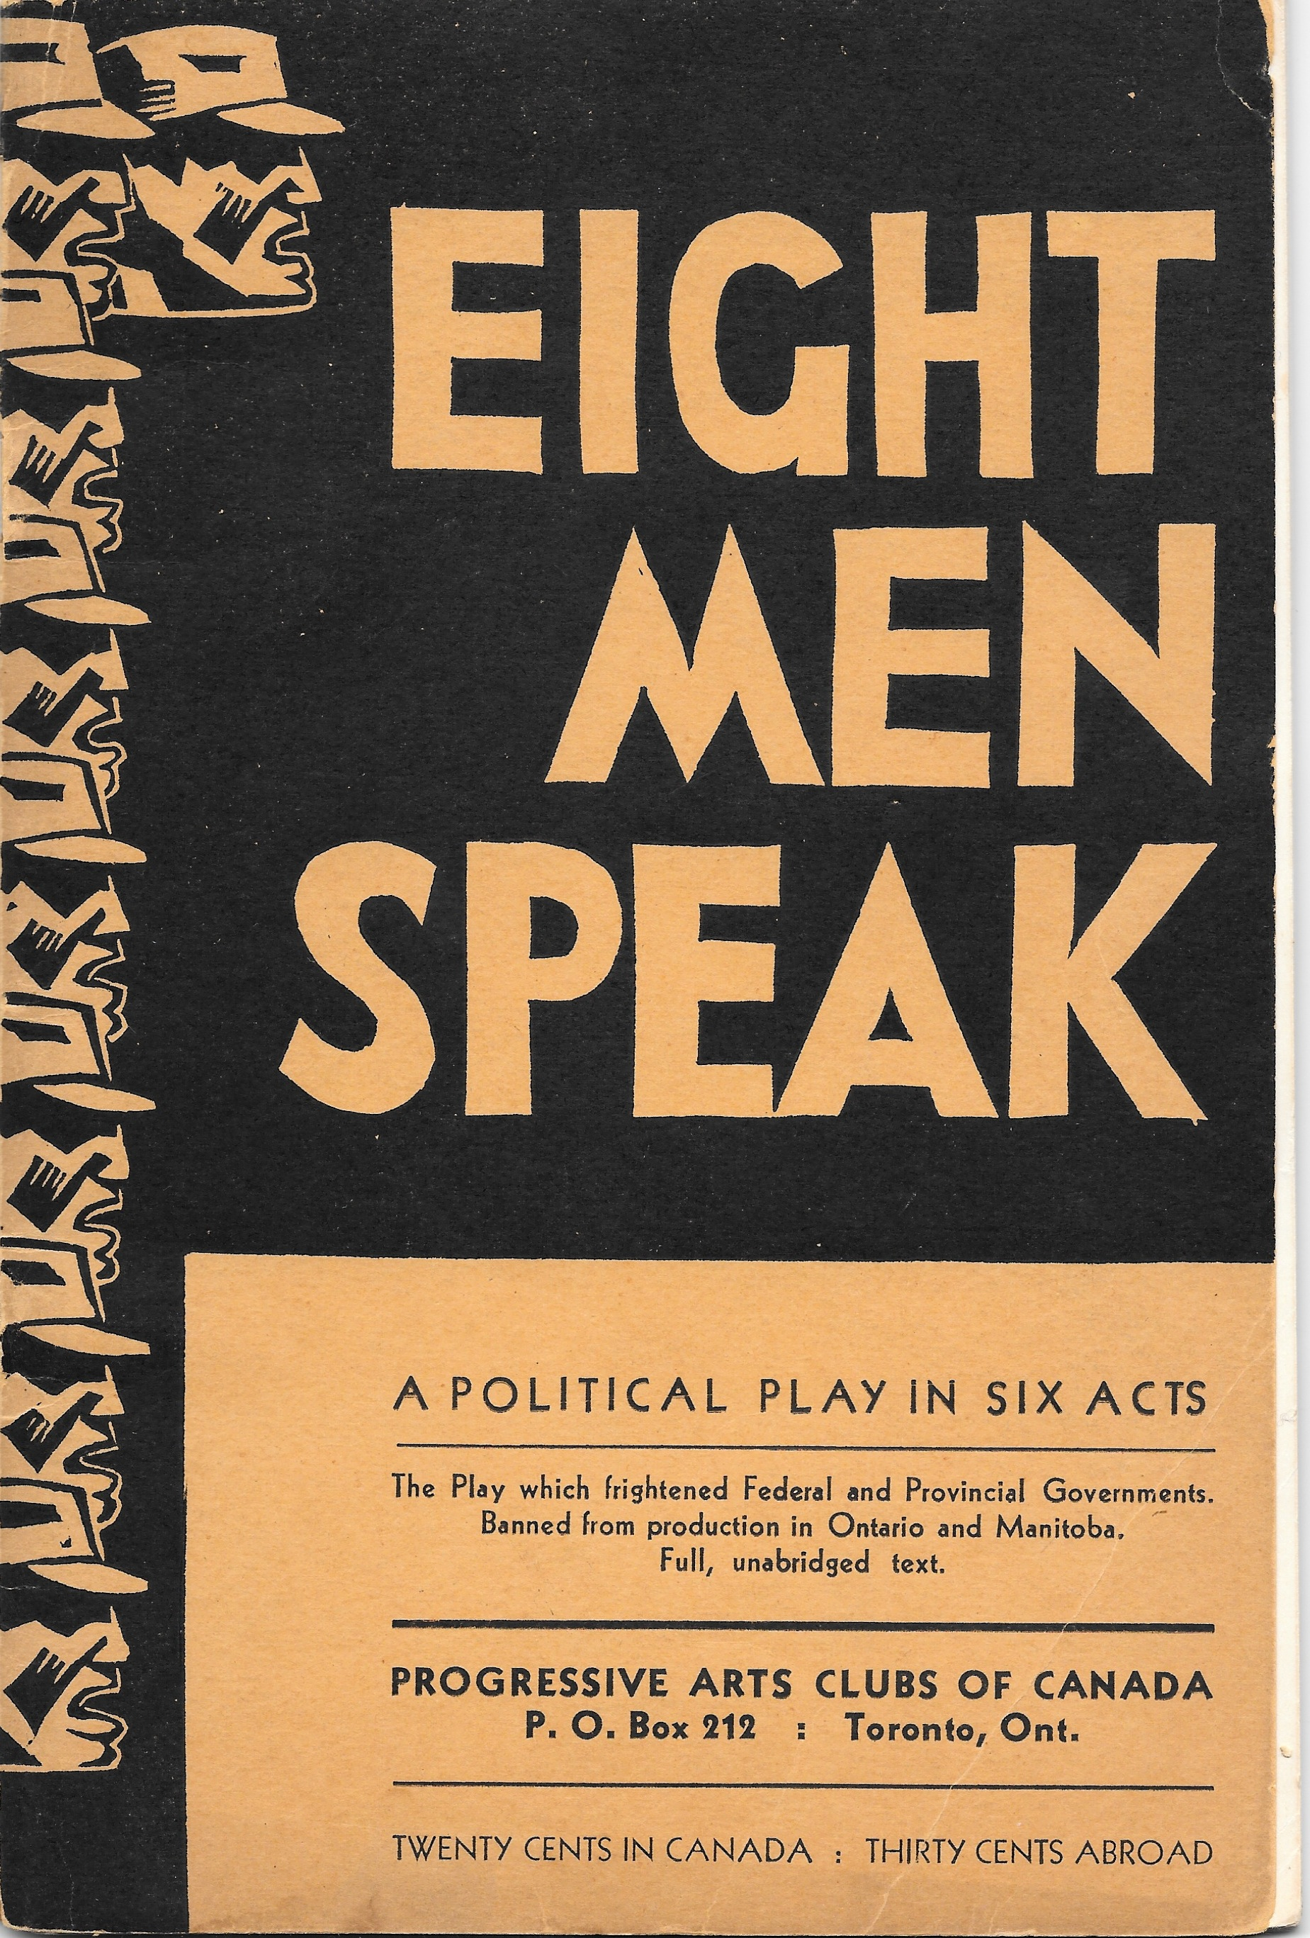

The cover of the banned 1934 edition of Eight Men Speak.
[Source: Collection of the author, Alan Filewod.]

